**Name:** Ria Rajan **Date:** 10/26/2021

**Lab section:** 270-007

**Show your work!!!**

**Acquire**

Week: 10

Date: March 18 Year: **2019**

Data: How do we really feel about Women Leaders?

**Source Article/Visualization:** The Reykjavik Index for Leadership

<https://www.makeovermonday.co.uk/data/data-sets-2018/>

**Represent**

**Critique**

Critique the visualization: what do you like about it, dislike about it, what do you plan to do differently? Remove this text and highlighting before submitting your work.

While this is a great visualization, there were a few problems with it that I noticed. When I first looked at the graph, I didn’t really understand the findings. The graph first of all doesn’t disclose in the title or anywhere that it is related to the view of women leaders by country. It just says the “Reykjavik Index leadership findings.” Me as the viewer doesn’t know what the Reykjavik index is and what the G7 countries are. So that is a lack of communication to the viewer that results in a misunderstanding of the graph. Secondly, I did not understand what the numbers meant in relation to each country. I had to go into the data source and find the original article to understand the meaning of this graph. The Reykjavik index is an index that measures out of 100 how far each country has to go until gender does not define leadership. In the article, this graph made perfect sense because its findings were being explained. However, the graph cannot stand on its own because there is not enough information conveying the meaning of the graph.

NEW: Based on your knowledge of the Periodic Table of Visualization Methods (discussed in class this week), discuss which one of the 6 categories does the visualization you provided in the Represent stage falls in. Identify the method most closely related to the visualization in the Represent Stage and discuss the characteristics: overview, detail, detail AND overview, divergent thinking, convergent thinking. Refer to Week 10 Readings to assist with categorizing the visualization.

The original visualization is in a specific chart type that doesn’t exactly match anything in the periodic table of visualization methods. However, it most closely resembles a bar graph and can be called a circular bar chart. In the periodic Table of Visualization Methods, a bar chart is yellow which is categorized as data visualization, it is a process visualization, and it is overview.

**Mine**

What question(s) are you attempting to answer? Remove this text and highlighting before submitting your work.

How are each of the G7 countries (inter-governmental political forum) doing with gender equality on a scale of 100?

**Filter**

**Show** (display, list, make it visible) the filtered data.

**Stakeholders**

* Who is your audience? What assumptions did you make? What visualization tool/software did you use?
* The general audience is the whole world. Gender equality affects everyone and the G7 countries are some of the top countries in the world that have the highest populations and are very representative of the state of the whole world and very influential to the rest of the world. More specifically however, this visualization’s main target audience are the officials of these countries in knowing the state at which gender equality stands and leaders around the world and specifically women around the world knowing how far we are from complete gender equality.
* An assumption I made was that this is not really representative of worldwide views of female leaders as it’s only taking the top countries in the world when a lot of underdeveloped countries are the ones facing gender gap, higher male to female ratios, and inequality.

**What to submit:** This document in PDF format only (if you do not know how to do this, ask).

**Choose the best layout** for your makeover visualization: Portrait or Landscape, Remove the page of the layout that you DO NOT choose. No blank pages!

**Refine (Makeover – Portrait View)**

Use an additional page if necessary. Remember, the purpose of visualization is *“insight.”* Take and include a screenshot of your visualization and include it below. Use Data Visualization Best Practices (see data visualization checklist).

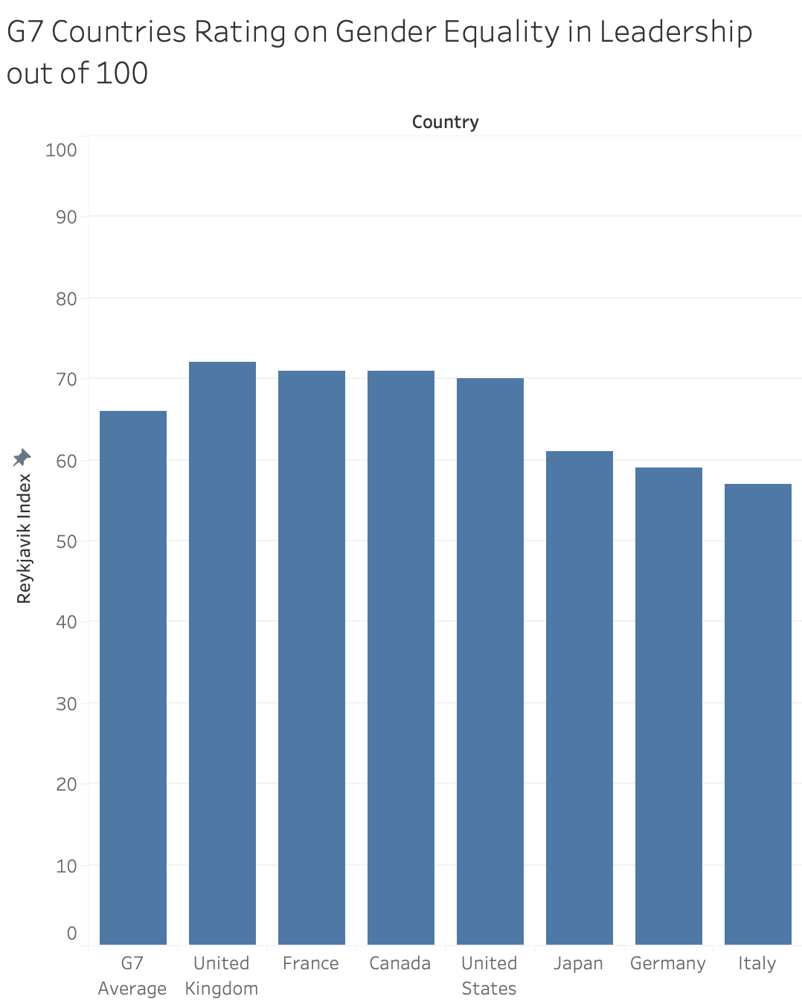

Figure Caption. This graph shows the G7 countries (inter-governmental political forum) rating out of 100 on Gender Equality using the Reykjavik Index.

**Resources**

Data Visualization Checklist:

<http://stephanieevergreen.com/wp-content/uploads/2016/10/DataVizChecklist_May2016.pdf>

How to give constructive criticism:

<https://personalexcellence.co/blog/constructive-criticism/>

Sample Makeovers

<https://www.makeovermonday.co.uk/gallery/>

**Grading Rubric**

|  |  |  |  |
| --- | --- | --- | --- |
| **Excellent**  **(21-25 pts)** | **Good**  **(10-20 pts)** | **Fair**  **(5 – 9 pts)** | **Needs Improvement (0 – 4 pts)** |
| Meets **ALL** or most of these: Makeover is esthetically pleasing (color, perception), best practices followed (insightful), Correct dataset downloaded; provided an interesting point of view of the data; critiqued previous makeover, critique is constructive (indicates one thing that is done well, and one thing that could be done differently, what will be done to improve the visualization), assumptions (more than one) are listed. | Meets **MOST** of these: Makeover is esthetically pleasing (color, perception), best practices followed (insightful), Correct dataset downloaded; provided an interesting point of view of the data; critiqued previous makeover, critique is constructive (indicates one thing that is done well, and one thing that could be done differently, what will be done to improve the visualization), assumptions (more than one) are listed. | Consistently meets **SOME** of these: Makeover is esthetically pleasing (color, perception), best practices followed (insightful), Correct dataset downloaded; provided an interesting point of view of the data; critiqued previous makeover, critique is constructive (indicates one thing that is done well, and one thing that could be done differently, what will be done to improve the visualization), assumptions (more than one) are listed. | Little to no evidence of the understanding of the data visualization process.  Lackluster makeover or no makeover.  Little effort. |